**Managerial Economics:**

**A Problem-Solving Approach**

**4th Edition**

*End-of-Chapter Individual Problems - Key*

Table of Contents

Chapter 1 7

1-1 Goal Alignment at a Small Manufacturing Concern 7

1-2 Goal Alignment at a Small Manufacturing Concern (cont.) 7

1-3 Goal Alignment at a Small Manufacturing Concern (cont.) 8

1-4 Goal Alignment at New York City schools 8

1-5 Goal Alignment between Airlines and Flight Crews 8

1-6 Goal Alignment between Hospitals and the British Government 8

Chapter 2 9

2-1 Airline Delays 9

2-2 Selling Used Cars 9

2-3 Flood Insurance 9

2-4 France’s Labor Unions Force Early Closing Times 9

2-5 Kraft and Cadbury 10

2-6 Price of Breast Reconstruction Versus Breast Augmentation 10

Chapter 3 11

3-1 Concert Opportunity Cost 11

3-2 Concert Opportunity Cost 2 11

3-3 Housing Bubble 11

3-4 Opportunity Cost 11

3-5 Starbucks 12

3-6 Dropping University Courses 12

Chapter 4 13

4-1 Extent Versus Discrete Problems 13

4-2 Game Day Shuttle Service 13

4-3 Paid for Grades 13

4-4 Supplier Bids 14

4-5 Processing Insurance Claims 14

4-6 Copier Company 14

Chapter 5 15

5-1 George’s T-Shirt Shop 15

5-2 Net Present Value 15

5-3 Doctor’s Human Capital 15

5-4 Solar Panel Installation 15

5-5 Toy Trucks 16

5-6 Running a Hotel During a Recession 16

Chapter 6 17

6-1 Elasticity of T-Shirt Sales 17

6-2 Demand Curves with Same Values 17

6-3 Increasing Movie Ticket Prices 17

6-4 Nike Demand (inelastic) 17

6-5 Promotional Pricing 18

6-6 Bar Nuts 18

Chapter 7 19

7-1 Scale and Scope 19

7-2 Brand Extensions 19

7-3 Rangers’ T-Shirts 19

7-4 Average and Marginal Costs 19

7-5 Learning Curves 20

7-6 Multiconcept Restaurants Are a Growing Trend 20

Chapter 8 21

8-1 Widget Market 21

8-2 Cotton Prices 21

8-3 Hand Sanitizer 21

8-4 Chocolate Candy Bars Market 22

8-5 Demand Shifts 22

8-6 Valentine’s Day 23

Chapter 9 24

9-1 Faculty Housing Benefits 24

9-2 Snacks, Beer, and Marijuana 24

9-3 Entry and Elasticity 24

9-4 Competitive Industries 25

9-5 Economic Profit 25

9-6 Economics Versus Business 25

Chapter 10 26

10-1 High Rivalry 26

10-2 Increasing Customer Value 26

10-3 Intangible Resources 26

10-4 Five Forces and the Airline Industry 26

10-5 Smartphone Market 27

10-6 Salons and Teeth Whitening 27

Chapter 11 28

11-1 Explain the Peso Devaluation 28

11-2 Flight to Safety 28

11-3 The Russian Ruble 28

11-4 The Carry Trade 29

11-5 Dollar Devaluation 29

11-6 Effect of Expectations on the Exchange Rate 29

Chapter 12 30

12-1 Parking Lot Optimization 30

12-2 Parking at Cowboys Stadium 30

12-3 App Pricing for Droids 30

12-4 Macintosh Versus iPhone 31

12-5 Concert Prices 31

12-6 Radio Stations and Rock Concerts 31

Chapter (13)-14 32

14-1 Barbie Dolls and Accessories 32

14-2 German Brothels 32

14-3 Selling Salsa 32

14-4 Microwave Ovens 32

14-5 Music Pricing 33

14-6 Bundling 33

Chapter 15 35

15-1 To Vote or Not to Vote 35

15-2 To Vote or Not to Vote Part II 35

15-3 Compatibility 35

15-4 Salary Negotiation 35

15-5 Renegotiating Employment Contracts 36

15-6 Entry Game with Withdrawal 37

Chapter 16 38

16-1 Newspaper Bargaining 38

16-2 Airline Merger 38

16-3 House Closing 38

16-4 A City and Its Unions 38

16-5 Entering International Markets 39

16-6 PBMs 39

Chapter 17 41

17-1 Global Expansion 41

17-2 Game Show Uncertainty 41

17-3 Ad Agencies 42

17-4 Disposing of Used Assets 42

17-5 Saint Petersburg Gambles 42

17-6 Hiring 43

Chapter 18 44

18-1 Effects of Collusion 44

18-2 Reserve Prices 44

18-3 Reserve Prices II 45

18-4 Asset Auctions in Sweden 45

18-5 Art Auctions 45

18-6 Contractor Bidding 45

Chapter 19 47

19-1 Leasing Residuals 47

19-2 College Degrees Required for Police Officers 47

19-3 Bicycle Insurance and Information Asymmetry 47

19-4 Job Auction 47

19-5 “Soft Selling” and Adverse Selection 48

19-6 Hiring Employees 48

Chapter 20 49

20-1 Extended Warranties 49

20-2 Business Loan 49

20-3 Locator Beacons for Lost Hikers 49

20-4 Auto Insurance 49

20-5 BPO Services 50

20-6 Frequent Flyers 50

Chapter 21 51

21-1 Real Estate Agents 51

21-2 Airline Departures 51

21-3 Incentive Conflicts 51

21-4 Public School Principals 51

21-5 Venture Capital 52

21-6 Meeting Milestones 52

Chapter 22 53

22-1 Transfer Pricing 53

22-2 Transfer Prices Set by Headquarters 53

22-3 Chargebacks 54

22-4 Divisional Profit Measure 54

22-5 Furniture Forecasting 54

22-6 Jet Turbine Design 55

Chapter 23 56

23-1 Local Phone Companies 56

23-2 Integration of Physician Groups and Testing Services 56

23-3 Online Cosmetics 56

23-4 Wedding Dresses 56

23-5 Herbicide Integration 57

23-6 Loyalty Payments 57

# Chapter 1

*Short Answer Key:*

## 1-1 Goal Alignment at a Small Manufacturing Concern

The owners of a small manufacturing concern have hired a manger to run the company with the expectation that he will buy the company after five years. Compensation of the new Vice President is a flat salary plus 75% of the first $150,000 profit, then 10% of profit over $150,000. Purchase price for the company is set at 4.5 times earnings (profit), computed as average annual profitability over the next five years.

a. Plot the annual compensation of the vice president as a function of annual profit.

*Assume for now the VP has a base salary of 50,000. If so, when P≤$150000, his compensation can be determined by the equation C = 50000+0.75(P). When P≥150000, compensation is determined by the equation C=(50000+0.75(150000)) + 0.1P, which means C=162500+0.1P. The plot for compensation can be seen below.*

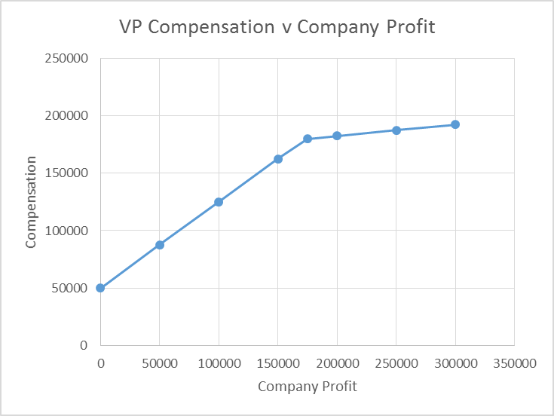 

b. Assume the company will be worth $10million in five years. Plot the profit of buying the company as a function of annual profit.

*The purchase price will be 4.5x earnings, calculated as 4.5x average annual profitability. Therefore, the profitability of the purchase can be seen by the equation Ppurchase = 10,000,000 – 4.5(Pannual). The plot of this equation can be seen below.*

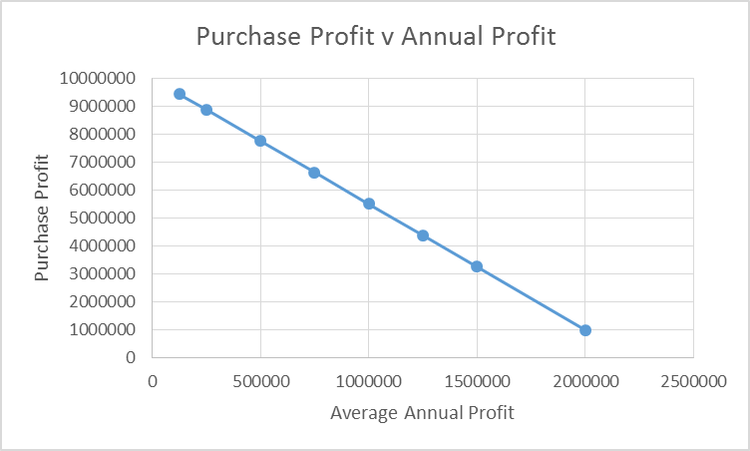 

## 1-2 Goal Alignment at a Small Manufacturing Concern (cont.)

Does this contract align the incentives of the new vice president with the profitability goals of the owners?

*No. Both the purchase price and the profit sharing create perverse incentives. The VP keeps $0.75 of each dollar earned up to $150,000, but only $0.10 of each dollar earned after $150K. Since earning more requires more effort (increasing marginal effort), he has little incentive to earn more than $150,000. And every dollar the VP earns raises the price that he will eventually pay for the company by $4.50, effectively penalizing him for increasing company profitability.*

## 1-3 Goal Alignment at a Small Manufacturing Concern (cont.)

Re-design the contract to better align the incentives of the new vice president with the profitability goals of the owners.

*One approach would be to establish a purchase price at the initiation of the contract. This would encourage the VP to make the company as profitable as possible, as it the increases to his marginal wealth of 10% above 150000 are not offset by the dramatic increases in purchase price. Also, this encourages him to make the company as profitable as possible as it will ultimately be his once the 5 years have passed.*

## 1-4 Goal Alignment at New York City schools

1,800 New York City teachers who lost their jobs earlier this year have yet to apply for another job despite the fact that there are 1,200 openings. Why not?

*New York is the only city in the U.S. where teachers are guaranteed pay for life even if their school closes and they no longer have a permanent job. The policy costs DOE more than $100 million per year in salary and benefits. Those teachers go into the Absent Teacher Reserve pool, where they can be used as substitutes. The average salary for an ATR pool teacher? $82,000, with some making $100,000. Some teachers have been in the pool since 2006.*

## 1-5 Goal Alignment between Airlines and Flight Crews

Planes frequently push back from the gate on time, but then wait 2 feet away from the gate until it is time to queue up for take-off. This increases fuel consumption, and increases the time that passengers must sit in a cramped plane awaiting take-off. Why does this happen?

*Airlines are often evaluated and measured by their “on time” performance metrics. As this refers to boarding times rather than the time of actual departure, airlines would rather board the planes on time and wait on the tarmac than leaves passengers waiting at the gate.*

## 1-6 Goal Alignment between Hospitals and the British Government

In 2008, the Labour party in Britain promised that patients would have to wait for no more than four hours to be seen in an emergency room. How is the National Health Service meeting this performance goal?

*To meet this performance goal, seriously ill patients are being kept in ambulances. Thousands of people a year are having to wait outside the emergency departments because the trusts will not let them in until they will be able to be treated within four hours in accordance with the Labour pledge and government targets. In addition to keeping people outside, this also has reduced the ability of the ambulances to respond to emergency calls, leading to serious problems throughout the region.*